**Group members**

Dang Thi Thao My - 15905067

Bui Nguyen Thien Khanh - 15907679

Nguyen Anh Quan - 15905072

Le Huynh Anh Tuan - 1325907

**Supervisor:** MSc. Truong Phuoc Loc

**Product Owner:** Mr. To Hoa Duy Man

**Software Requirements Specification**

**Performance testing dashboard**

Version 1.0 – Released date: 10/17/2016

**Status**:

Approved by:

Released by: Capstone team (ETI1)

Internal

Document Revision History

|  |  |  |  |
| --- | --- | --- | --- |
| Version | Date | Changed by | Modifications |
| 1.0 | 10.17.2016 | Capstone team | Initial |
| 1.1 | 12.20.2016 | Capstone team | Correct minor mistakes |
|  |  |  |  |

Contents

1. Introduction 5

1.1. Purpose 5

1.2. Scope 5

1.3. Definitions, Acronyms and abbreviations 6

1.4. Coordinators 6

1.5. Overview 6

2. Software Requirements 7

2.1. Operational Requirements 7

2.2. Functional Requirements 8

2.2.1. Product requirement index 8

2.2.2. User management 10

2.2.3. Project management 19

2.2.4. Test management 27

2.2.5. Script/File management 37

2.2.6. Report management 42

2.2.7. Agent Management 46

2.2.8. Other functional requirements 49

2.3. User Interface Requirements 50

2.4. External Interface Requirements 52

2.5. Special Characteristics 52

2.6. Software Safety Requirements 52

3. Project Execution Related Requirements 53

3.1. Development Environment 53

3.2. Design requirements 53

3.3. Coding requirements 53

3.4. Error handling requirements 53

3.5. Resource requirements 54

3.6. Risk management 54

3.7. Training Requirements 56

4. Testing Requirements 57

5. Product Quality Characteristics 58

6. Open Source Usage 59

7. Other Requirements 60

8. Legal, Security and Confidential Requirements 61

9. Quality Assurance Activities 62

10. Performance Requirements 63

11. Data Protection and Information Security Requirements 65

11.1. Data storage 65

11.2. Data transmission 65

11.3. Information security requirements: 65

12. Software Acceptance Criteria 66

13. Deliverables 67

13.1. List of Deliverables 67

13.2. Installation Support 67

13.3. Delivery 67

14. Requirements Acceptance Statement 68

15. Annexure 69

15.1. References 69

# Introduction

## Purpose

The Software Requirements Specifications (SRS) document provides detailed requirements description of Performance Testing Dashboard Project. It specifies, analyses and presents the non-functional and functional featured requirements, demonstrate the workflow and interfaces of the system. It includes a list of mandatory constrains and policies during the development of the dashboard to ensure best practice in design and implementation for the first release.

The SRS is intended to propose to the client – BOSCH RBVH Validation Service Team for first approval and a reference for developers to build up the first release 1.0 of the dashboard.

## Scope

The software system is a website application dashboard that monitor and execute performance test run and report under Jmeter Core API. It will be initially used internal in BOSCH RBVH Company by RBVH Validation Team for doing performance testing on a Website and later expanding external customers outside of BOSCH Company. This system will be the replacement of the old and offline Desktop application that currently using in the company, decrease the complexity on configuration of Jmeter to run performance testing without the requirement of using Jmeter GUI.

The project is looking forward to maximizing in sharing the test reports and test configuration between testers on the team through website. By that, the testers can increase productivity by instantly show reports to customers and store test on web application server. The dashboard will allow User to work on projects that they are assigned by Administrator, create Test Suites to run Jmeter Test with automated configuration parameters and uploaded Jmeter scripts, customized personal parameters for each tests, automated generated reports and real-time test run report.

There are specific objectives that the dashboard must be met:

* **Objective 1:** The PTD need to have ability to show performance testing result both in offline-mode and in real-time.
* **Objective 2**: Have the ability to zoom in and zoom out, show the value at the specific point on graph when test execution is complete.
* **Objective 3:** Need to be able to manage the Report. Have some features such as report comparison, report export, etc.
* **Objective 4:** Need a user management which can be linked with Bosch user and also able to create new user.
* **Objective 5:** Need a Script management which use to manage performance script. It also need a File Uploader where user can upload their Script.
* **Objective 6:** The P.T.D also require an automation system to co-operate with. This automation system will have ability to automate run performance test from the Jmx script which user can upload from dashboard. It also have ability to automate collect performance testing report, depending on the requirement of the customer then it automate send the result back to the customer when test execution is complete.

## Definitions, Acronyms and abbreviations

Abbreviations used in this document

Table 1 - Definitions

|  |  |
| --- | --- |
| Terms | Definitions |
| Admin | Administrator |
| API | Application Programming Interface |
| BOSCH RBVH | Robert Bosch Engineering and Solution Vietnam |
| E-R | Entity Relationship |
| GUI | Graphic User Interface |
| Jmeter | Java open source used for testing and measure performance |
| OSS | Open Source Software |
| PTD | Performance Testing Dashboard |
| RS | Requirement Specification |
| SRS | Software Requirement Specification |
| Test Suites | A Test Suite is a container of test parameters and script that executed for testing purpose |
| User | The person using the application |

## Coordinators

|  |  |
| --- | --- |
| Name | Responsibility |
| Mr. Nguyen Huu Khiem – RBVH/ETI1 | Group Manager – BOSCH Coordinator |
| Mr. To Hoa Duy Man – RBVH/ETI14 | Project Manager – Product Owner |
| Mr. Lam Quang Vu - HCMUS | HCMUS Coordinator |
| Mr. Petteri Kaskenpalo | AUT Coordinator |

## Overview

The chapter from 2 to 5 describes details the requirements and descriptions of each module and features should be on the dashboard for developers to track down the project progress and from chapter 6 and 11 constrains and legalities to make assure the quality and security of the dashboard. From chapter 12 are agreements and commitment between project team and clients of deliverables and acceptance criteria of the dashboard. Finally are the annexure in support of technical explanation and guidelines, including references.

# Software Requirements

Describe the general factors that affect the product and its requirements. In a sense, this section tells the requirements in plain English for the consumption of customer and developers. Section 3 and the following will contain specifications written for the developers.

## Operational Requirements

|  |  |  |
| --- | --- | --- |
| Category | Assumption | Status |
| GUI |  | Valid/ Invalid |
|  | Bootstrap 3 |  |
|  | AngularJS 2 |  |
| Database |  |  |
|  | MySQL |  |
| Functionality |  |  |
|  | User Authentication |  |
|  | Jmx Script Management |  |
|  | Show Reports |  |
|  | Run Jmeter Script |  |
|  | Result Export |  |
|  | File Uploaded |  |
|  | Real-Time report |  |
|  | Master Machine Configuration |  |
|  | Slave Machine Configuration |  |
| Design |  |  |
|  | Architecture Diagrams |  |
|  | Prototype |  |
| Implementation |  |  |
|  | Source Code Delivery |  |
|  | First release |  |
|  | Final release |  |
| Environment |  |  |
|  | Java Development Toolkit 1.8 (JDK 1.8) |  |
|  | Maven 3.4 |  |
|  | Tomcat 7 |  |
|  | Spring Boot Framework |  |
| Data |  |  |
|  | Test Data file |  |
|  | Bosch User Information |  |
| Control |  |  |
|  | Source Tree Control Code |  |
|  | Team Foundation Sever (TFS) |  |
|  | Spring Tool Suite |  |
|  | Jmeter |  |
| Operating System |  |  |
|  | Window OS System |  |

## Functional Requirements

### Product requirement index

|  |  |  |  |
| --- | --- | --- | --- |
| No. | Key | Summary | Module |
| 1 | RE1-1 | Log in | User management |
| 2 | RE1-1 | Log out | User management |
| 3 | RE1-3 | View user profile | User management |
| 4 | RE1-4 | Edit user profile | User management |
| 5 | RE1-5 | Create new user | User management |
| 6 | RE1-6 | Delete user | User management |
| 7 | RE1-7 | Edit user account | User management |
| 8 | RE1-8 | View user list | User management |
| 9 | RE2-1 | View project list as a user | Project management |
| 10 | RE2-2 | View project list as an admin | Project management |
| 11 | RE2-3 | Create new project | Project management |
| 12 | RE2-4 | View project detail as a user | Project management |
| 13 | RE2-5 | View project detail as an admin | Project management |
| 14 | RE2-6 | Edit project | Project management |
| 15 | RE2-7 | Delete project | Project management |
| 16 | RE3-1 | View list of project test suites | Test management |
| 17 | RE3-2 | View test suite detail | Test management |
| 18 | RE3-3 | Create a test suite | Test management |
| 19 | RE3-4 | Edit a test suite | Test management |
| 20 | RE3-5 | Run a test suite | Test management |
| 21 | RE3-6 | Delete a test suite | Test management |
| 22 | RE4-1 | View file | File/Script management |
| 23 | RE4-2 | Upload file | File/Script management |
| 24 | RE4-3 | Delete file | File/Script management |
| 25 | RE4-4 | Download file | File/Script management |
| 26 | RE5-1 | Watch real-time report | Report management |
| 27 | RE5-2 | View final report | Report management |
| 28 | RE5-3 | Export reports | Report management |
| 29 | RE5-4 | View test run history | Report management |
| 30 | RE3-7 | Run a test suite in distributed mode | Test management |
| 31 | RE6-1 | Create new agent | Agent management |
| 32 | RE6-2 | Delete agent | Agent management |
| 33 | RE6-3 | Edit agent | Agent management |
| 34 | RE6-4 | View agent list | Agent management |

### User management

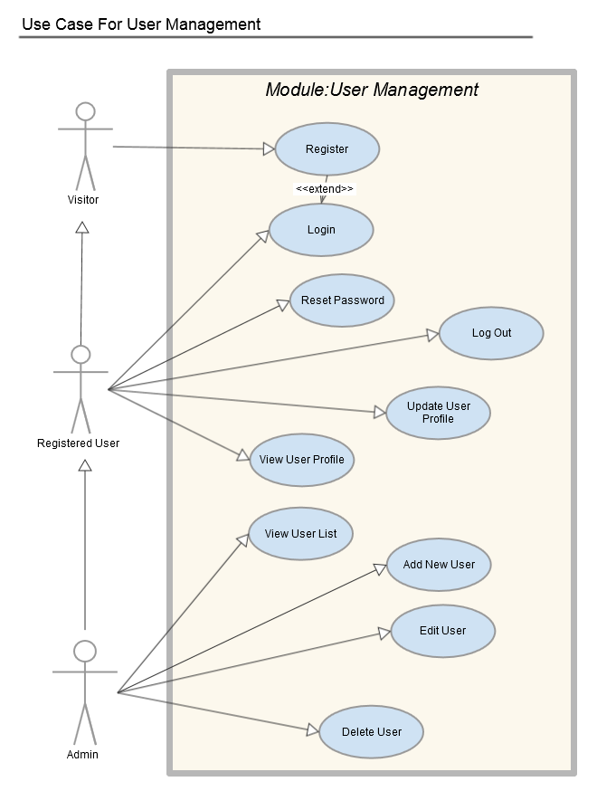

|  |  |
| --- | --- |
| RE1-1 | Log in |
| Description | The user wants to access the system. |
| Stakeholders | Testers, project manager, admin |
| Actors | Guest |
| Trigger | This use case starts when a user wants to log in to the system and goes to the login page. |
| Inputs | |  |  |  | | --- | --- | --- | | **Field Name** | **Type** | **Remarks** | | **username** | **Text** | **Username must at least 6 character and does not contain any special characters.** | | **password** | **password** | **Password must at least 8 character, does not contain any special characters, contain at least 1 upper case + 1 lower case + 1 number.** | |
| Preconditions | The user is not logged in to the system |
| Main Success Scenario | 1. The user opens the login page 2. The user enters the username 3. The user enters the password 4. The user clicks the “Sign in” button 5. The system validates the entered username and password 6. The user is signed in and returned to the home page as a Current User. 7. The use case ends. |
| Alternative Scenarios | Automatic forwarding to the login page:  Accessing protected functions will automatically forward the user to the login page in case that he/she’s not logged in yet |
| Success End Condition | The user has access to the system  The page that the user wanted to access prior to authentication is displayed (automatic forwarding)  The system created a new session  Optional: the system might want to set a cookie ("remember me") |
| Failed End Condition | If the User entered an invalid username and/or password, the following occurs:   1. An error message is being displayed 2. The system prompts the User to re-enter the valid information. 3. The user has no access to the system |
| Special Requirements | + The System’s interface must be user-friendly.  + The respond time must be under 5 seconds. |

|  |  |
| --- | --- |
| RE1-2 | Log out |
| Description | The current user closes his/her current session and stops accessing the system. |
| Stakeholders | Testers, project manager, admin |
| Actors | Current User |
| Trigger | The user wants to end his/her session |
| Inputs | None |
| Preconditions | The user is logged in to the system |
| Main Success Scenario | 1. The user clicks the “Logout” button/link. 2. The system closes the session and forwards the user to the login page. 3. The use case ends. |
| Alternative Scenarios | Automatic forwarding to the login page:   * Accessing protected functions will automatically forward the user to the login page in case that he/she’s not logged in yet |
| Success End Condition | The user is logged out |
| Failed End Condition | * The user is still logged in * A error message is displayed |
| Special Requirements | + The System’s interface must be user-friendly.  + The respond time must be under 5 seconds. |

|  |  |
| --- | --- |
| RE1-3 | View User Profile |
| Description | An User want to view his/her information |
| Stakeholders | Testers, project manager, admin |
| Actors | Current User |
| Trigger | This use case starts when an user accesses the “View Profile” feature of the system |
| Inputs | None. |
| Preconditions | The administrator is logged into the system. |
| Main Success Scenario | 1. The User Click on his/her profile link 2. The system displays the corresponding information 3. Use Case ends. |
| Alternative Scenarios | None. |
| Success End Condition | System redirects to User Profile view.  System should show following field for Work space:   |  |  |  | | --- | --- | --- | | **Field Name** | **Type** | **Remarks** | | **username** | **Text** | **Username must at least 6 character and does not contain any special characters.** | | **email** | **Text** | **Email must have a valid type** | | **Reset Password** | **Button** |  | |
| Failed End Condition | * A error message is displayed * The user's credentials are not displayed. |
| Special Requirements | + The System’s interface must be user-friendly.  + The respond time must be under 5 seconds. |

|  |  |
| --- | --- |
| RE1-4 | Edit User Profile |
| Description | An User want to edit his/her information |
| Stakeholders | Testers, project manager, admin |
| Actors | Current User |
| Trigger | This use case starts when an user accesses the “Edit Profile” feature of the system |
| Inputs | |  |  |  | | --- | --- | --- | | **Field Name** | **Type** | **Remarks** | | email | Text | Email must have a valid type | |
| Preconditions | The user is logged into the system. |
| Main Success Scenario | 1. The User Click on his/her profile link 2. The system displays the corresponding information 3. The user edits the information accordingly and submits. 4. The system updates the information. 5. Use Case ends. |
| Alternative Scenarios | * Clicking the cancel button returns the user back to the user profile |
| Success End Condition | * The user's credentials are updated. |
| Failed End Condition | * A error message is displayed * The user's credentials are not updated. |
| Special Requirements | + The System’s interface must be user-friendly.  + The respond time must be under 5 seconds. |

|  |  |
| --- | --- |
| RE1-5 | Create new User |
| Description | An administrator of the System creates a new user to the database |
| Stakeholders | Testers, project manager, admin |
| Actors | Administrator |
| Trigger | The administrator want to create new user |
| Inputs | |  |  |  | | --- | --- | --- | | **Field Name** | **Type** | **Remarks** | | username | Text | Username must at least 6 character and does not contain any special characters. | | password | password | Password must at least 8 character, does not contain any special characters, contain at least 1 upper case + 1 lower case + 1 number. | | Password repeated | password | Same as password | | Email-address | Text | Email must have a valid email type | |
| Preconditions | The administrator is logged into the system. |
| Main Success Scenario | 1. The administrator clicks the “Add New User” button/link 2. The administrator opens the "Add New User" form 3. The administrator enters the user's data (Username, Password, email) 4. The administrator click the “Create” button/link 5. The system validates the entered data 6. The system creates the account |
| Alternative Scenarios | Clicking the cancel button returns the admin back to the User list page |
| Success End Condition | The user account is created |
| Failed End Condition | * A error message is displayed * No user account was created |
| Special Requirements | + The System’s interface must be user-friendly.  + The respond time must be under 5 seconds. |

|  |  |
| --- | --- |
| RE1-6 | Delete User |
| Description | An administrator of the System want to delete a user from the database |
| Stakeholders | Testers, project manager, admin |
| Actors | Administrator |
| Trigger | This use case starts when an administrator accesses the “Delete User” feature of the system |
| Inputs | None. |
| Preconditions | The administrator is logged into the system. |
| Main Success Scenario | 1. The System displays the current list of Users. 2. The Administrator selects the user he/she wants to delete. 3. The system displays the warning delete for the Administrator to confirm it again. 4. The Administrator clicks “Delete” button. 5. The system deletes the information. 6. Use Case ends. |
| Success End Condition | * The User is deleted. |
| Failed End Condition | * A error message is displayed * The User is not deleted. |
| Special Requirements | + The System’s interface must be user-friendly.  + The respond time must be under 5 seconds. |

|  |  |
| --- | --- |
| RE1-7 | Edit User Account |
| Description | An administrator of the System want to edit information of a user from the database |
| Stakeholders | Testers, project manager, admin |
| Actors | Administrator |
| Trigger | This use case starts when an administrator accesses the “Edit User” feature of the system |
| Inputs | |  |  |  | | --- | --- | --- | | **Field Name** | **Type** | **Remarks** | | Email-address | Text | Email must have a valid type | | Admin | Radio button | Is Admin or General User | | Active | Radio button | Is Activate or Deactivate | |
| Preconditions | The administrator is logged into the system. |
| Main Success Scenario | 1. The System displays the current list of Users. 2. The Administrator selects the user he/she wants to edit. 3. The system displays the corresponding information to the user selected. 4. The Administrator edits the information accordingly and submits. 5. The system updates the information. 6. Use Case ends.   Note: The username and password cannot be changed by administrator. |
| Alternative Scenarios | Clicking the cancel button returns the administrator back to the user list |
| Success End Condition | The user's credentials are updated. |
| Failed End Condition | * A error message is displayed * The user's credentials are not updated. |
| Special Requirements | + The System’s interface must be user-friendly.  + The respond time must be under 5 seconds. |

|  |  |
| --- | --- |
| RE1-8 | View User List |
| Description | An administrator of the System want to edit information of a user from the database |
| Stakeholders | Testers, project manager, admin |
| Actors | Administrator |
| Trigger | This use case starts when an administrator accesses the “User List” feature of the system |
| Inputs | None. |
| Preconditions | The administrator is logged into the system. |
| Main Success Scenario | 1. The Administrator clicks on “User List” feature. 2. The System displays the current list of Users. 3. Use Case ends. |
| Alternative Scenarios | None. |
| Success End Condition | The user's list is displayed. |
| Failed End Condition | A error message is displayed  The user's list is not displayed. |
| Special Requirements | * The System’s interface must be user-friendly. * The respond time must be under 5 seconds. |

### Project management

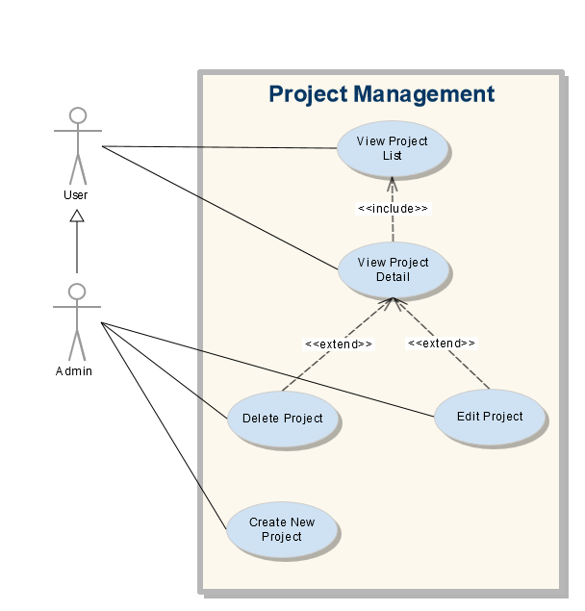

|  |  |
| --- | --- |
| RE2-1 | View Project List. |
| Description | User want to display all the project that he/she currently enroll in. |
| Stakeholders | Testers, project manager, admin |
| Actors | User |
| Trigger | View Project List |
| Priority | Required |
| Feature | User View |
| Inputs | None |
| Preconditions | The user is logged in  User must enroll at least 1 project |
| Main Success Scenario | 1. User will navigate the side bar menu on the left. 2. User click on “Project” tab. 3. User click on “View project list”. 4. System redirects to project list view. |
| Alternative Scenarios | 3a. Do not have any result   1. System will notify that he/she was not currently in any project |
| Success End Condition | System redirect to Project List View and list all the project that user currently enroll in.  System should show following fields for Work space:   |  |  |  | | --- | --- | --- | | **Field Name** | **Type** | **Remarks** | | Project ID | Number | Show the project ID in database | | Project Name | Text | Show the project name, must unique | | Description | Text | Maximum 255 characters | | Status | Option | Choose between New and On-going | | Created Day | Date | Save the date when the project created | | Last Updated | Date | Automatically save the date the project last updated | | Members | Number | Total number of users enroll in that project | |
| Failed End Condition | System will redirect user to login page and display error message. |
| Special Requirements | * System’s interface must be user-friendly. * The respond time must be under 1 minute. |

|  |  |
| --- | --- |
| RE2-2 | View Project List. |
| Description | User want to display all the project that he/she currently enroll in. |
| Stakeholders | Testers, project manager, admin |
| Actors | System Administrator |
| Trigger | View Project List |
| Priority | Required |
| Feature | Admin View |
| Inputs | None |
| Preconditions | The user is logged in under administrator account. |
| Main Success Scenario | 1. Admin will navigate the side bar menu on the left. 2. Admin click on “Project” tab. 3. Admin click on “View project list”. 4. System redirects to project list view. |
| Alternative Scenarios | None. |
| Success End Condition | System redirect to Project List View and display all the project in the system will admin view.  System should show following fields for Work space:   |  |  |  | | --- | --- | --- | | **Field Name** | **Type** | **Remarks** | | Project ID | Long | Show the project ID in database | | Project Name | Text | Show the project name, must unique | | Description | Text | Maximum 255 characters | | Status | Option | Choose between New and On-going | | Created Day | Date Time | Save the date when the project created | | Last Updated | Date Time | Automatically save the date the project last updated | | Members | Integer | Total number of users enroll in that project | | Edit Project button | Button | Shortcut to go Edit Project Page | | Delete Project button | Button | Fast delete chosen project. | | Create New Project | Button | Create new project. | |
| Failed End Condition | System will redirect user to login page and display error message. |
| Special Requirements | * System’s interface must be user-friendly. * The respond time must be under 1 minute. * All the admin function for project must be arranged sensible and easy to use. |

|  |  |
| --- | --- |
| RE2-3 | Create New Project |
| Description | Admin want to create new project with specific name, description, status and project members. |
| Stakeholders | Testers, project manager, admin |
| Actors | System Administrator |
| Trigger | Create new project in the system |
| Inputs | |  |  |  |  | | --- | --- | --- | --- | | **Field Name** | **Required** | **Type** | **Remarks** | | Project Name | Y | Input Text (255) | + Project name must at least 8 characters and does not contain special characters.  + Project name must be unique. | | Project Status | N | Option | + Admin will have 2 options: New and On-going.  + Default is New | | Project Description | N | Input Text (255) | + Project description contains maximum 255 characters. | | Project Members | N | Admin choose from database | Admin can add existing users in the system or group into project members | |
| Preconditions | The user is logged in under administrator account. |
| Main Success Scenario | 1. Admin will navigate the side bar menu on the left. 2. Admin click on “Project” tab. 3. Admin click on “View project list”. 4. System redirects to project list view for admin. 5. Admin will click on “Create New Project” button on top-right screen. 6. Admin navigates to Create Project view. 7. Admin fill in all/required field and submit. 8. System redirects to project list with success message. |
| Alternative Scenarios | None. |
| Success End Condition | System saves data to database then redirects to Project List View and show success message. |
| Failed End Condition | System will stay in same view and display error messages. |
| Special Requirements | * System’s interface must be user-friendly. * The respond time must be under 1 minute. * All the admin function for project must be arranged sensible and easy to use. |

|  |  |
| --- | --- |
| RE2-4 | View Project Detail. |
| Description | User want to display the project detail for more specific information as well as test list. |
| Stakeholders | Testers, project manager, admin |
| Actors | User |
| Trigger | View Project Detail as User |
| Inputs | None. |
| Preconditions | User must be authorized user to view the project detail. |
| Main Success Scenario | 1. User will navigate the side bar menu on the left. 2. User click on “Project” tab. 3. User click on “View project list”. 4. System redirects to project list view. 5. User click on any project name to view project detail |
| Alternative Scenarios | 3a. User can click on one of three latest projects on dropdown menu. |
| Success End Condition | System redirects to Project Detail view.  System should show following fields for Work space:   |  |  |  | | --- | --- | --- | | **Field Name** | **Type** | **Remarks** | | Category | Option | Show test list depend on type of test. | |  |  |  | | Search | Input text | Search for specific test with given information | | Title | Link/text | Display text name or user can click on to visit the test detail. | | Description | Text | Display description for each test. | | State | Text | Display that current status of the test. | | Time | Date Time | Display the time that test last run or created | |
| Failed End Condition | System will redirect user to login page and display error message. |
| Special Requirements | * System’s interface must be user-friendly. * The respond time must be under 1 minute. * Any authorized members will able to view the project detail. |

|  |  |
| --- | --- |
| RE2-5 | View Project Detail. |
| Description | User want to display the project detail for more specific information as well as test list. |
| Stakeholders | Testers, project manager, admin |
| Actors | System Administrator |
| Trigger | View Project Detail as Admin |
| Inputs | None. |
| Preconditions | The user is logged in under administrator account. |
| Main Success Scenario | 1. User will navigate the side bar menu on the left. 2. User click on “Project” tab. 3. User click on “View project list”. 4. System redirects to project list view. 5. User click on any project name to view project detail |
| Alternative Scenarios | None. |
| Success End Condition | System redirects to Project Detail view.  System should show following fields for Work space:   |  |  |  | | --- | --- | --- | | **Field Name** | **Type** | **Remarks** | | Add Test button | Button | Quickly create a new test in current project | | Category | Option | Show test list depend on type of test. | | Search | Input text | Search for specific test with given information | | Title | Link/text | Display text name or user can click on to visit the test detail. | | Description | Text | Display description for each test. | | State | Text | Display that current status of the test. | | Time | Date Time | Display the time that test last run or created | |
| Failed End Condition | System will redirect user to login page and display error message. |
| Special Requirements | * System’s interface must be user-friendly. * The respond time must be under 1 minute. |

|  |  |
| --- | --- |
| RE2-6 | Edit Project |
| Description | Admin to change some information of dedicated project. |
| Stakeholders | Testers, project manager, admin |
| Actors | System Administrator |
| Trigger | Edit Project Detail as admin role. |
| Inputs | |  |  |  |  | | --- | --- | --- | --- | | **Field Name** | **Required** | **Type** | **Remarks** | | Project Name | Y | Input Text (255) | + Project name must at least 8 characters and does not contain special characters.  + Project name must be unique. | | Project Status | N | Option | + Admin will have 2 options: New and On-going.  + Default is New | | Project Description | N | Input Text (255) | + Project description contains maximum 255 characters. | | Project Members | N | Admin choose from database | Admin can add existing users in the system or group into project members | |
| Preconditions | The user is logged in administrator account. |
| Main Success Scenario | 1. Admin will navigate the side bar menu on the left. 2. Admin click on “Project” tab. 3. Admin click on “View project list”. 4. System redirects to project list view. 5. Admin must click on Edit button on right side of each project. 6. System redirects to Edit Project Form view. |
| Alternative Scenarios | 1. Admin will navigate the side bar menu on the left. 2. Admin click on “Project” tab. 3. Admin click on “Create New Project” tab. |
| Success End Condition | System saves data to database then redirects to Project Detail page and display success message. |
| Failed End Condition | System will stay in same view and display error messages. |
| Special Requirements | * System’s interface must be user-friendly. * The respond time must be under 1 minute. |

|  |  |
| --- | --- |
| RE2-7 | Delete Project |
| Description | Admin want to delete dedicated project. |
| Stakeholders | Testers, project manager, admin |
| Actors | System Administrator |
| Trigger | Delete project as admin role. |
| Inputs | None. |
| Preconditions | * The user is logged in administrator account. * The project test list must empty or deleted first. |
| Main Success Scenario | 1. Admin will navigate the side bar menu on the left. 2. Admin click on “Project” tab. 3. Admin click on “View project list”. 4. System redirects to project list view. 5. Admin must click on Delete button on right side of each project. 6. Alert pop-up will appear. 7. System redirects to project list view and display success message. |
| Alternative Scenarios | 3a.   1. Admin can click on project name to view project Detail 2. System redirects to Project Detail view. 3. Admin navigate to Delete Button. |
| Success End Condition | System redirects to Project Detail page and display success message. |
| Failed End Condition | System will redirect user to login page and display error message. |
| Special Requirements | * System’s interface must be user-friendly. * The respond time must be under 1 minute. * The project list must be emptied. |

### Test management

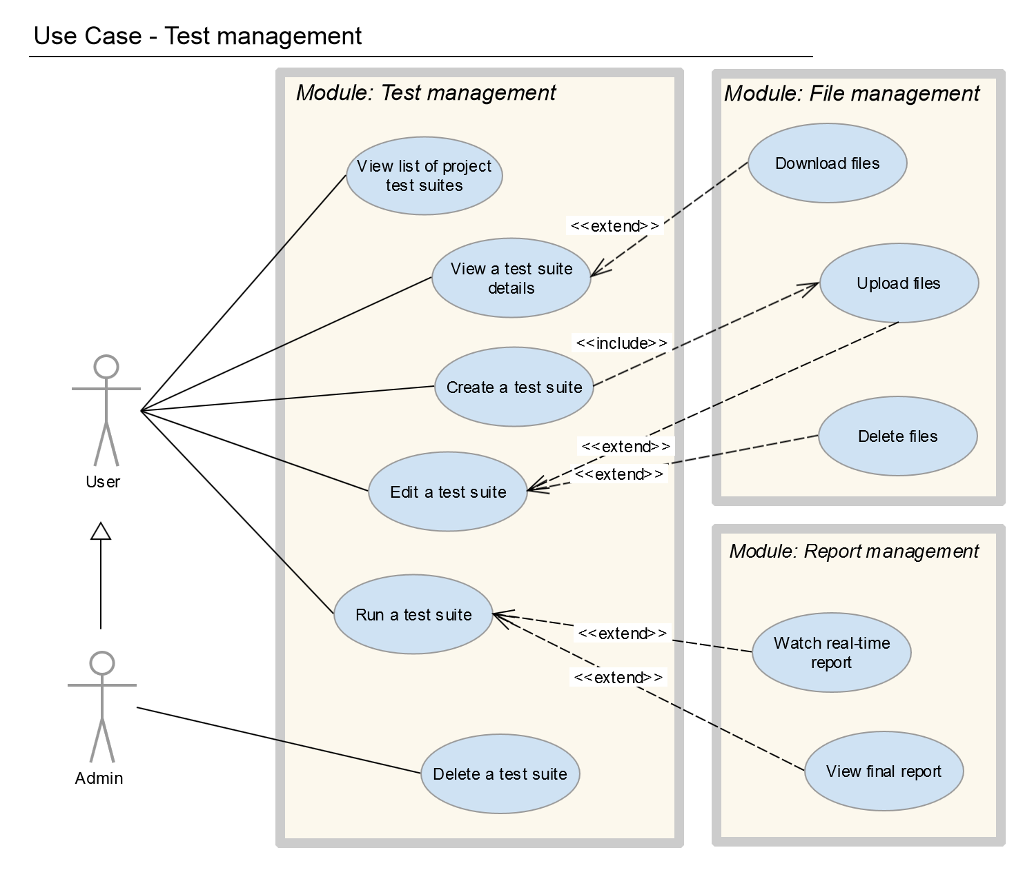

|  |  |
| --- | --- |
| RE3-1 | View list of project test suites |
| Summary | The user want to get the list of all test suites regarding to a specific project |
| Stakeholders | Testers, project manager, admin |
| Actors | User |
| Priority | Required |
| Feature | Test management |
| Trigger | The user want to see the list of all test suites of a project |
| Inputs | None |
| Preconditions | The user is logged in  The user belongs to the project having the test suite |
| Main Success Scenario | 1. The user selects a project from the list of projects on his/her project page.  2. The system shows the list of test suite names and some basic information including test descriptions and running status. |
| Alternative Scenarios | The user could get the test suite list page from the side bar menu. |
| Success End Condition | Technically none, the list of test suite with the following information is shown   |  |  |  | | --- | --- | --- | | **Field Name** | **Type** | **Remarks** | | Name | Link | Opens the test suite details page. | | Description | Text | Only 65 Characters are shown. | | Running status | Text | Show the test is running or not | | Time | Text | Last run time | |
| Failed End Condition | The system displays an error message |
| Special Requirements | + The System’s interface must be user-friendly.  + The respond time must be under 5 seconds. |

|  |  |
| --- | --- |
| RE3-2 | View test suite detail |
| Description | The user want to get the details of a test suite regarding to a specific project |
| Stakeholders | Testers, project manager, admin |
| Actors | User |
| Trigger | The user want to know the details of a test suite |
| Inputs | None |
| Preconditions | The user is logged in  The user belongs to the project having the test suite |
| Main Success Scenario | 1. The user selects a test suite from the list of test suites on the project detail page.  2. The system shows the test suite details including   |  |  |  | | --- | --- | --- | | **Field Name** | **Type** | **Remarks** | | Name | Text | The test suite name | | Threads | Number | Test parameter | | Ramp-up | Number | Test parameter | | Duration | Number | Test parameter | | Delay | Number | Test parameter | | Loop | Number | Test parameter | | Agent | Text | IP v4 format | | File Upload | File | script *.jmx, data *.csv, *.txt |   Or in detail advance mode:   |  |  |  | | --- | --- | --- | | **Field Name** | **Type** | **Remarks** | | Name | Text | The test suite name | | Threads Count Burst | Number | Test parameter | | Start Thread Count | Number | Test parameter | | Thread Number | Number | Test parameter | | Start Thread Ramp Up | Number | Test parameter | | Start Thread Period | Number | Test parameter | | Stop Thread Count | Number | Test parameter | | Stop Thread Period | Number | Test parameter | | Flight Time | Number | Test Parameter | | Thread Initial Delay | Number | Test parameter | | Agent | Text | IP v4 format | | File Upload | File | script *.jmx, data *.csv, *.txt |   And the run timeline. |
| Alternative Scenarios | The user could open the test suite detail page from an anchor on the corresponding report page. |
| Success End Condition | Technically none, but the user has known the details |
| Failed End Condition | The system displays an error message |
| Special Requirements | + The System’s interface must be user-friendly.  + The respond time must be under 5 seconds. |

|  |  |
| --- | --- |
| RE3-3 | Create a test suite |
| Description | The user creates a test suite after joining a project |
| Stakeholders | Testers, project manager, admin |
| Actors | User |
| Trigger | The user want to create test suite. Usually this happens when the user want to run a performance test suite. |
| Inputs | SIMPLE THREAD GROUP TEST FIELD:   |  |  |  | | --- | --- | --- | | **Field Name** | **Type** | **Remarks** | | Name | Text | The test suite name | | Threads | Number | Test parameter | | Ramp-up | Number | Test parameter | | Duration | Number | Test parameter | | Delay | Number | Test parameter | | Agent | Text | IP v4 format | | Loop | Number | Test parameter | | File Upload | File | script *.jmx, data *.csv, *.txt |   STEPPING THREAD GROUP TEST FIELD:   |  |  |  | | --- | --- | --- | | **Field Name** | **Type** | **Remarks** | | Name | Text | The test suite name | | Threads Count Burst | Number | Test parameter | | Start Thread Count | Number | Test parameter | | Thread Number | Number | Test parameter | | Start Thread Ramp Up | Number | Test parameter | | Start Thread Period | Number | Test parameter | | Stop Thread Count | Number | Test parameter | | Stop Thread Period | Number | Test parameter | | Flight Time | Number | Test Parameter | | Thread Initial Delay | Number | Test parameter | | Agent | Text | IP v4 format | | File Upload | File | script *.jmx, data *.csv, *.txt | |
| Preconditions | The user is logged in.  The user belongs to the project which the test belongs. |
| Main Success Scenario | 1. The user selects “create new test” button on the project test suite list page.  2. The system shows the test suite create form with the following fields  + Test suite name  + Test parameters: threads, ramp-up, agent, duration, delay ( simple)  + Test parameters: thread count burst, start thread count, thread number, start thread ramp up , start thread period, stop thread count , stop thread count, stop thread period, flight time, thread initial delay(advance)  + Browse button to upload files  3. The user provides the test suite data. Note that  + The name must be provided while test parameters can be omitted.  +Upload files must have a script with jmx extension and other files are optional depending on the test suite.  4. The user clicks “Save”  5. The system validates the test suite and saves the data, assigning it to the user. |
| Alternative Scenarios | The user could create test suite by click on the anchor create new test on the side bar or fill in the form on the home page. |
| Success End Condition | + Test suite is stored  + The project members see the test suite in the project test suite list. |
| Failed End Condition | The system displays an error message |
| Special Requirements | + The System’s interface must be user-friendly.  + The respond time must be under 5 seconds. |

|  |  |
| --- | --- |
| RE3-4 | Edit a test suite |
| Description | The user edits the test suite basic data |
| Stakeholders | Testers |
| Actors | User |
| Trigger | The user want to edit a test suite. Usually this happens before the test suite is run. |
| Inputs | SIMPLE THREAD GROUP TEST FIELD:   |  |  |  | | --- | --- | --- | | **Field Name** | **Type** | **Remarks** | | Name | Text | The test suite name | | Threads | Number | Test parameter | | Ramp-up | Number | Test parameter | | Duration | Number | Test parameter | | Delay | Number | Test parameter | | Agent | Text | IP v4 format | | File Upload | File | script *.jmx, data *.csv, *.txt |   STEPPING THREAD GROUP TEST FIELD:   |  |  |  | | --- | --- | --- | | **Field Name** | **Type** | **Remarks** | | Name | Text | The test suite name | | Threads Count Burst | Number | Test parameter | | Start Thread Count | Number | Test parameter | | Thread Number | Number | Test parameter | | Start Thread Ramp Up | Number | Test parameter | | Start Thread Period | Number | Test parameter | | Stop Thread Count | Number | Test parameter | | Stop Thread Period | Number | Test parameter | | Flight Time | Number | Test Parameter | | Thread Initial Delay | Number | Test parameter | | Agent | Text | IP v4 format | | File Upload | File | script *.jmx, data *.csv, *.txt | |
| Preconditions | The user is logged in.  The user belongs to the project which the test belongs. |
| Main Success Scenario | 1. The user clicks the edit button on the test suite detail page.  2. The system shows the test suite edit form with the following fields  + Test suite name  + Test parameters: threads, ramp-up, agent, duration, delay  + Test parameters: thread count burst, start thread count, thread number, start thread ramp up , start thread period, stop thread count , stop thread count, stop thread period, flight time, thread initial delay(advance)  + Browse button to upload files and a list of uploaded files. The user could download or delete any file.  3. The user might change the test suite data. Note that  + The name must be provided while test parameters can be omitted.  +Upload files must have a script with jmx extension and other files are optional depending on the test suite.  4. The user clicks “Save”  5. The system validates the test suite and saves the data, tracking the edit author and time. |
| Alternative Scenarios | None |
| Success End Condition | + Test suite data is updated |
| Failed End Condition | The system displays an error message |
| Special Requirements | + The System’s interface must be user-friendly.  + The respond time must be under 5 seconds. |

|  |  |
| --- | --- |
| RE3-5 | Run a test suite |
| Description | The user runs the test suite basic |
| Stakeholders | Testers |
| Actors | User |
| Trigger | The user want to run a test suite. Usually this happens after the test suite is edited or created. |
| Inputs | None |
| Preconditions | The user is logged in.  The user belongs to the project which the test belongs. |
| Main Success Scenario | 1. The user clicks the run button on the test suite detail page.  2. The system redirects to the real time report page showing test suite data and real time response charts. The charts includes   |  |  |  | | --- | --- | --- | | **Name** | **Type** | **Remarks** | | Hits per second | Line chart | Real- time, zoom | | Response over time | Line chart | Real- time, zoom | | Active threads over time | Line chart | Real- time, zoom | | Throughput | Line chart | Real-time, zoom |   The system is saving test run data while the test is running.  3. The user might zoom in/out the real time charts.  4. Then when the test suite finish running. The user might select the export button to save the report as pdf files.  5. The system saves the test run data. |
| Alternative Scenarios | None |
| Success End Condition | + Test report data is saved |
| Failed End Condition | The system displays an error message |
| Special Requirements | + The System’s interface must be user-friendly.  + The respond time must be under 5 seconds. |

|  |  |
| --- | --- |
| RE3-6 | Delete a test suite |
| Description | The user removes an existing test suite.  Note that: only users with the admin role can remove test suites. |
| Stakeholders | Admin |
| Actors | Admin, testers, project manager |
| Trigger | The user want to run a test suite. Usually this happens after the test suite is edited or created. |
| Inputs | None |
| Preconditions | The user is logged in.  The test suite is available. |
| Main Success Scenario | 1. The user browses the project test suites until he/she finds the test suite that shall be removed  2. The user opens the test suite and click the “Delete” button. Note that this button is only available if the current user is admin.  3. The system deletes the test suite. Ideally the test item will not be deleted physically, but only be marked as removed and made invisible to all users. |
| Alternative Scenarios | None |
| Success End Condition | + Test suite has been (logically) deleted  + The test suite is no longer visible |
| Failed End Condition | The system displays an error message  The test suite has not been deleted and still visible |
| Special Requirements | + The System’s interface must be user-friendly.  + The System must confirm the user on the delete action.  + The respond time must be under 5 seconds. |

|  |  |
| --- | --- |
| RE3-7 | Run a test suite in distributed mode (Alternative of RE3-5) |
| Description | The user runs the test suite basic with agents. |
| Stakeholders | Testers |
| Actors | User |
| Trigger | The user want to run a test suite in distributed mode. Usually this happens after the test suite is edited or created. |
| Inputs | None |
| Preconditions | The user is logged in.  The user belongs to the project which the test belongs.  The user tick distributed mode in test details.  The user choose the agent(s) to run or by default agent. |
| Main Success Scenario | 1. The user clicks the run button on the test suite detail page.  2. The system redirects to the real time report page showing test suite data and real time response charts. The charts includes   |  |  |  | | --- | --- | --- | | **Name** | **Type** | **Remarks** | | Hits per second | Line chart | Real- time, zoom | | Response over time | Line chart | Real- time, zoom | | Active threads over time | Line chart | Real- time, zoom | | Throughput | Line chart | Real-time, zoom |   The system is saving test run data while the test is running.  3. The user might zoom in/out the real time charts.  4. Then when the test suite finish running. The user might select the export button to save the report as pdf files.  5. The system saves the test run data. |
| Alternative Scenarios | None |
| Success End Condition | + Test report data is saved |
| Failed End Condition | The system displays an error message |
| Special Requirements | + The System’s interface must be user-friendly.  + The respond time must be under 5 seconds. |

### Script/File management

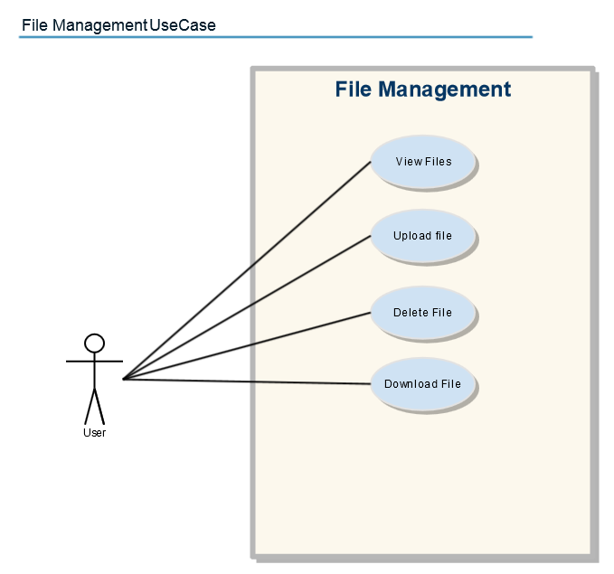

|  |  |
| --- | --- |
| RE4-1 | View File |
| Description | User view files that belong to the test that they are working in order to manage the files. |
| Stakeholders | Testers, project manager, admin |
| Actors | User |
| Priority | Optional |
| Feature | File management |
| Trigger | User wants to view the files of the test suite |
| Inputs | NONE |
| Preconditions | User must logged into the system.  User must enroll in at least 1 project the see the project list.  User must create a test to view and upload the files. |
| Main Success Scenario | 1. The User login to the dashboard 2. The User navigate to a project detail. 3. The User navigate to a Test Detail. 4. Show the files attached to the test on the File input tab of Test Detail. |
| Alternative Scenarios | Click “Change” on a test detail to navigate to edit form  Show Files of the test on the File input tab.   |  |  |  | | --- | --- | --- | | Field Name | Type | Remarks | | Name | Link | Done nothing | | Download button | Button | To download the file | | Delete button | Button | To delete file | | Browse button | Button | To upload file | | Type icon | Image | To show type of the file | |
| Success End Condition | Able to see the Files on File Input Tab.   |  |  |  | | --- | --- | --- | | Field Name | Type | Remarks | | Name | Link | Done nothing | | Download button | Button | To download the file | | Type icon | Image | To show type of the file | |
| Failed End Condition | The system displays an error message |
| Special Requirements | + The System’s interface must be user-friendly.  + The respond time must be under 5 seconds. |

|  |  |
| --- | --- |
| RE4-2 | Upload file |
| Description | User wants to upload scripts or data for a test run. Especially Jmeter script test. |
| Stakeholders | Testers, project manager, admin |
| Actors | User |
| Trigger | User wants to upload scripts or data for a test run. |
| Inputs | |  |  |  | | --- | --- | --- | | **Field Name** | **Type** | **Remarks** | | Name | Text | The test suite name | | Threads | Number | Test parameter | | Ramp-up | Number | Test parameter | | Agent | Text | IP v4 format | | File Upload | File | script *.jmx, data *.csv, *.txt | |
| Preconditions | User must logged into the system.  User must enroll in at least 1 project the see the project list.  User must create a test to view and upload the files. |
| Main Success Scenario | 1. The User login to the dashboard 2. The User navigate to a project detail. 3. The User navigate to a Test Detail. 4. Click “Change” to navigate to edit form  |  |  |  | | --- | --- | --- | | Field Name | Type | Remarks | | Name | Link | Done nothing | | Download button | Button | To download the file | | Delete button | Button | To delete file | | Browse button | Button | To upload file | | Type icon | Image | To show type of the file |  1. Click “Browse” on file input tab to select uploaded files. 2. Show information of the uploaded files and size summary. 3. Click “Save” to confirm upload. 4. Success notification appear. |
| Alternative Scenarios | 3a. The User create a new Test then proceed to 5.  7a. Alert pop-up if total size of file upload are over 5 MBs and reset the file inputs.  8a. Alert notification appear to show and decline upload suspicious chosen files. |
| Success End Condition | Test saved successfully.  Shown new uploaded files information like:   |  |  |  | | --- | --- | --- | | Field Name | Type | Remarks | | Name | Link | Done nothing | | Download button | Button | To download the file | | Type icon | Image | To show type of the file | |
| Failed End Condition | The test cannot upload <Filenames>!  Also shown uploaded files that passed the security check. |
| Special Requirements | + The System’s interface must be user-friendly.  + The respond time must be under 5 seconds. |

|  |  |
| --- | --- |
| RE4-3 | Delete File |
| Description | User wants to delete a file belong to a test that are no longer necessary for file management purposes or replacement of new version of that file.  . |
| Stakeholders | Testers, project manager, admin |
| Actors | User |
| Trigger | The user wants to delete a file |
| Inputs | |  |  |  | | --- | --- | --- | | **Field Name** | **Type** | **Remarks** | | Name | Text | The test suite name | | Threads | Number | Test parameter | | Ramp-up | Number | Test parameter | | Agent | Text | IP v4 format | | File Upload | File | script *.jmx, data *.csv, *.txt | |
| Preconditions | User must logged into the system.  User must enroll in at least 1 project the see the project list.  User must create a test to view and upload the files. |
| Main Success Scenario | 1. The User login to the dashboard 2. The User navigate to a project detail. 3. The User navigate to a Test Detail. 4. Click “Change” to navigate to edit form  |  |  |  | | --- | --- | --- | | Field Name | Type | Remarks | | Name | Link | Done nothing | | Download button | Button | To download the file | | Delete button | Button | To delete file | | Browse button | Button | To upload file | | Type icon | Image | To show type of the file |  1. Click delete icon to delete a file 2. Confirm delete 3. Press OK to delete a file, navigate the page to edit form. 4. Press Save to save the modification. |
| Alternative Scenarios | 5a. Proceed to 8. If no file belongs to the test.  7a. Cancel the delete then proceed to 5. Or 8. |
| Success End Condition | A file has been deleted! |
| Failed End Condition | The system displays an error message |
| Special Requirements | + The System’s interface must be user-friendly.  + The respond time must be under 5 seconds. |

|  |  |
| --- | --- |
| RE4-4 | Download File |
| Description | Download existing on the test. |
| Stakeholders | Testers, project manager, admin |
| Actors | User |
| Trigger | User wants to download a file |
| Inputs | Test Detail – None.  Test Edit Form :   |  |  |  | | --- | --- | --- | | **Field Name** | **Type** | **Remarks** | | Name | Text | The test suite name | | Threads | Number | Test parameter | | Ramp-up | Number | Test parameter | | Agent | Text | IP v4 format | | File Upload | File | script *.jmx, data *.csv, *.txt | |
| Preconditions | User must logged into the system.  User must enroll in at least 1 project the see the project list.  User must create a test to view and upload the files. |
| Main Success Scenario | 1. The User login to the dashboard 2. The User navigate to a project detail. 3. The User navigate to a Test Detail.  |  |  |  | | --- | --- | --- | | Field Name | Type | Remarks | | Name | Link | Done nothing | | Download button | Button | To download the file | | Type icon | Image | To show type of the file |  1. The User click download icon to download a file 2. The system sent the file from the server to the User’s PC. |
| Alternative Scenarios | 4a. The User navigate to Edit Form by click “Change” button and proceed to 4.   |  |  |  | | --- | --- | --- | | Field Name | Type | Remarks | | Name | Link | Done nothing | | Download button | Button | To download the file | | Delete button | Button | To delete file | | Browse button | Button | To upload file | | Type icon | Image | To show type of the file | |
| Success End Condition | The user can download the file |
| Failed End Condition | File not found error. |
| Special Requirements | + The System’s interface must be user-friendly.  + The respond time must be under 5 seconds. |

### Report management

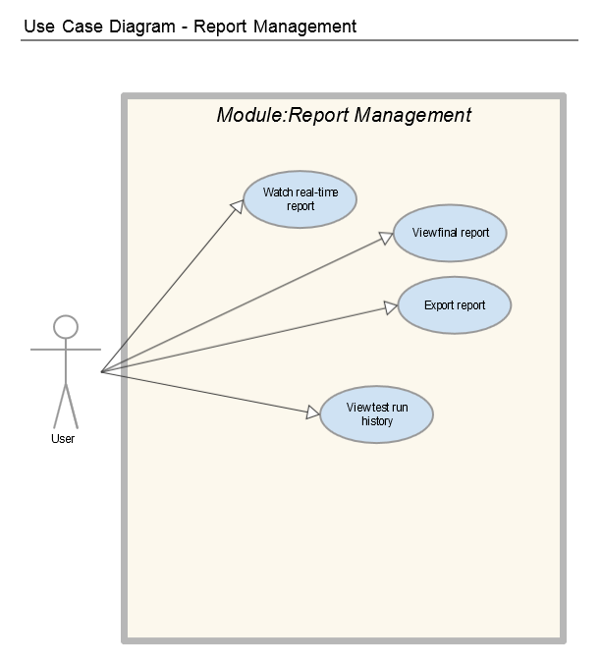

|  |  |
| --- | --- |
| RE5-1 | Watch Real-time Report |
| Description | During the test execution, tester want to observe the real-time progress of the test. |
| Stakeholders | Testers, project manager, admin |
| Actors | User |
| Trigger | View Real-time report after execute the test. |
| Inputs | None. |
| Preconditions | * The user is logged in. * Test parameters must be inputted or test script was uploaded. |
| Main Success Scenario | 1. User will navigate to test list page. 2. User create new test or use exists test suite. 3. User input necessary parameters for test or upload a test script. 4. User click on Save button 5. System will redirects user to test detail page. 6. User click on Run button. 7. User will wait 15s for system configuration 8. System redirects to Real-time report page. |
| Alternative Scenarios | None. |
| Success End Condition | After progress time, user will be able to watch the updating chart. Chart will be updated with new point every 1 second. |
| Failed End Condition | Error messages will appear and list all of errors with guidance. |
| Special Requirements | * System’s interface must be user-friendly. * The delay must less than 1 minute. * The real-time progress must able to display different transactions and types of report. |

|  |  |
| --- | --- |
| RE5-2 | View Final Report |
| Description | After the test execution, tester want to display the report for specific test. |
| Stakeholders | Testers, project manager, admin |
| Actors | User |
| Trigger | View Real-time report after execute the test. |
| Inputs | None. |
| Preconditions | * The user is logged in. * Test must be executed once. |
| Main Success Scenario | 1. User will navigate to test list page. 2. System will display all the tests in the project 3. User click on any test name to view the test detail. 4. User click run to execute the test. 5. System will redirects from Test Detail Page to Test Report page. 6. System display all information of the recent test executions. |
| Alternative Scenarios | 4b. Click test history ( if test has been executed previously)  5b. Click the previous report , the test detail page will redirected to the report page based on the Id. |
| Success End Condition | Types of report will be displayed with can be arranged by:   * Type: Active Threads over Time, Response Time over Time, Hit per second. * Transaction. |
| Failed End Condition | Error messages will appear and list all of errors with guidance. |
| Special Requirements | * System’s interface must be user-friendly. * The delay must less than 1 minute. * The report must able to display different transactions and types of report. * Able to export the report as PNG or Jpeg format. |

|  |  |
| --- | --- |
| RE5-3 | Export report |
| Description | After the display the report for specific test, user wants to print out the report into pdf file. |
| Stakeholders | Testers, project manager, admin |
| Actors | User |
| Trigger | The user want to export report. |
| Inputs | None. |
| Preconditions | * The user is logged in. * Test must be executed once. |
| Main Success Scenario | 1. User will navigate to report page of a specific test. 2. System will display all the metrics and data in report page. 3. User click on Export button. 4. System will download the Exported report file in PDF format to the user machine. |
| Alternative Scenarios | None. |
| Success End Condition | Report is successfully exported in PDF format.  Types of report will be displayed in the pdf with can be arranged by:   * Type: Active Threads over Time, Response Time over Time, Hit per second. * Transaction. |
| Failed End Condition | Error messages will appear and list all of errors with guidance. |
| Special Requirements | * System’s interface must be user-friendly. * The delay must less than 1 minute. * The report must able to display different transactions and types of report. * Able to export the report as PNG or Jpeg format. |

|  |  |
| --- | --- |
| RE5-4 | View test run history |
| Description | After multiple executions of the same test. The user want to review the previous result report of the same test. |
| Stakeholders | Testers, project manager, admin |
| Actors | User |
| Trigger | The user want view history of the test report. |
| Inputs | None. |
| Preconditions | * The user is logged in. * Test must be executed once. |
| Main Success Scenario | 1. User will navigate to test report page. 2. User click to History tab 3. System will display all reports has been created by the test. 4. Use Case end. |
| Alternative Scenarios | None. |
| Success End Condition | Successfully view the history of test executions and linked reports. |
| Failed End Condition | Error messages will appear and list all of errors with guidance. |
| Special Requirements | * System’s interface must be user-friendly. * The delay must less than 1 minute. |

### Agent Management

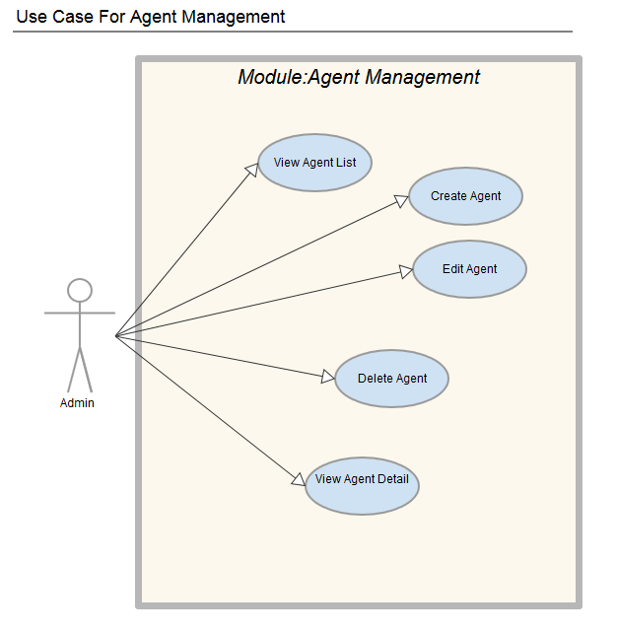

|  |  |
| --- | --- |
| RE6-1 | Create new Agent |
| Description | An administrator of the System creates a new agent computer to the database |
| Stakeholders | Testers, project manager, admin |
| Actors | Administrator |
| Trigger | The administrator want to create new agent |
| Inputs | |  |  |  | | --- | --- | --- | | **Field Name** | **Type** | **Remarks** | | name | Text | Name does not contain any special characters. | | port | Integer | Port contains 4-digit-number. | | status | Option | Only have two menu Online and Disconnect | | IP Address | Text | Must be a valid IPv4 address format. | | Description | Text | Text length must not exceed 255 characters. | |
| Preconditions | The administrator is logged into the system. |
| Main Success Scenario | 1. The administrator clicks the “Add New Agent” button/link 2. The administrator opens the "Add New Agent" form 3. The administrator enters the agent's data (name, port, IP address) 4. The administrator click the “Create” button/link 5. The system validates the entered data 6. The system creates the account |
| Alternative Scenarios | Clicking the cancel button returns the admin back to the User list page |
| Success End Condition | The user account is created |
| Failed End Condition | * A error message is displayed * No user account was created |
| Special Requirements | + The System’s interface must be user-friendly.  + The respond time must be under 5 seconds. |

|  |  |
| --- | --- |
| RE6-2 | Delete Agent |
| Description | An administrator of the System want to delete an agent computer from the database |
| Stakeholders | Testers, project manager, admin |
| Actors | Administrator |
| Trigger | This use case starts when an administrator accesses the “Delete Agent” feature of the system |
| Inputs | None. |
| Preconditions | The administrator is logged into the system. |
| Main Success Scenario | 1. The System displays the current list of Agents. 2. The Administrator selects the agent he/she wants to delete. 3. The system displays the warning delete for the Administrator to confirm it again. 4. The Administrator clicks “Delete” button. 5. The system deletes the information. 6. Use Case ends. |
| Success End Condition | * The Agent is deleted. |
| Failed End Condition | * A error message is displayed * The Agent is not deleted. |
| Special Requirements | + The System’s interface must be user-friendly.  + The respond time must be under 5 seconds. |

|  |  |
| --- | --- |
| RE6-3 | Edit Agent Information |
| Description | An administrator of the System want to edit information of an agent from the database |
| Stakeholders | Testers, project manager, admin |
| Actors | Administrator |
| Trigger | This use case starts when an administrator accesses the “Edit Agent” feature of the system |
| Inputs | |  |  |  | | --- | --- | --- | | **Field Name** | **Type** | **Remarks** | | name | Text | Name does not contain any special characters. | | port | Integer | Port contains 4-digit-number. | | status | Drop-down text menu | Only have two menu Online and Disconnect | | IP Address | Text | Must be a valid IP address format. | | Description | Text | Text length must not exceed 255 characters. | |
| Preconditions | The administrator is logged into the system. |
| Main Success Scenario | 1. The System displays the current list of Agents. 2. The Administrator selects the agent he/she wants to edit. 3. The system displays the corresponding information to the agent selected. 4. The Administrator edits the information accordingly and submits. 5. The system updates the information. 6. Use Case ends. |
| Alternative Scenarios | Clicking the cancel button returns the administrator back to the agents list |
| Success End Condition | The agent’s credentials are updated. |
| Failed End Condition | * A error message is displayed * The agent's credentials are not updated. |
| Special Requirements | + The System’s interface must be user-friendly.  + The respond time must be under 5 seconds. |

|  |  |
| --- | --- |
| RE6-4 | View Agent List |
| Description | An administrator of the System want to edit information of an agent from the database |
| Stakeholders | Testers, project manager, admin |
| Actors | Administrator |
| Trigger | This use case starts when an administrator accesses the “Agent List” feature of the system |
| Inputs | None. |
| Preconditions | The administrator is logged into the system. |
| Main Success Scenario | 1. The Administrator clicks on “Agent List” feature. 2. The System displays the current list of Agents. 3. Use Case ends. |
| Alternative Scenarios | None. |
| Success End Condition | The agent list is displayed. |
| Failed End Condition | A error message is displayed  The agent list is not displayed. |
| Special Requirements | * The System’s interface must be user-friendly. * The respond time must be under 5 seconds. |

|  |  |
| --- | --- |
| RE6-5 | View Agent Detail |
| Description | An administrator of the System want to get the detail of an agent |
| Stakeholders | Testers, project manager, admin |
| Actors | Administrator |
| Trigger | This use case starts when an administrator click on an Agent |
| Inputs | None. |
| Preconditions | The administrator is logged into the system. |
| Main Success Scenario | 1. The System displays the current list of Agents. 2. The Administrator selects the agent he/she wants to get the detail. |
| Alternative Scenarios |  |
| Success End Condition | System redirects to Agent Detail view.  System should show following fields:   |  |  |  | | --- | --- | --- | | **Field Name** | **Type** | **Remarks** | | name | Text | Name does not contain any special characters. | | port | Integer | Port contains 4-digit-number. | | status | Drop-down text menu | Only have two menu Online and Disconnect | | IP Address | Text | Must be a valid IP address format. | | Description | Text | Text length must not exceed 255 characters. | |
| Failed End Condition | * System will redirect admin to Agent list page and display error message. |
| Special Requirements | + The System’s interface must be user-friendly.  + The respond time must be under 5 seconds. |

### Other functional requirements

|  |  |
| --- | --- |
| No. | Module |
| 1 | REST API |
| 2 | Distributed test RE3 |
| 3 | Report analysis RE5 |

## User Interface Requirements

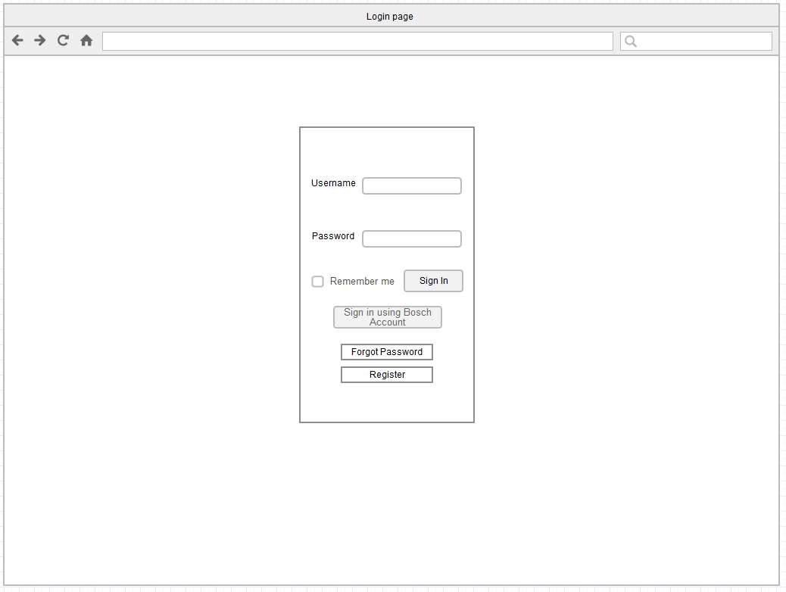

Figure 1: UI Login Page for "Login" use case scenarios

|  |  |
| --- | --- |
| **Requirement Tag ID** | **Login Page** |
| Source/Trigger | “Login” use case |
| Input | |  |  |  | | --- | --- | --- | | **Field Name** | **Type** | **Remarks** | | username | Text | Username must at least 6 character and does not contain any special characters. | | password | password | Password must at least 8 character, does not contain any special characters, contain at least 1 upper case + 1 lower case + 1 number. | |
| Description | Guest be able to use their username and password to log in to the system. Guest also have ability to click “Register“, “reset password” link on this page. |

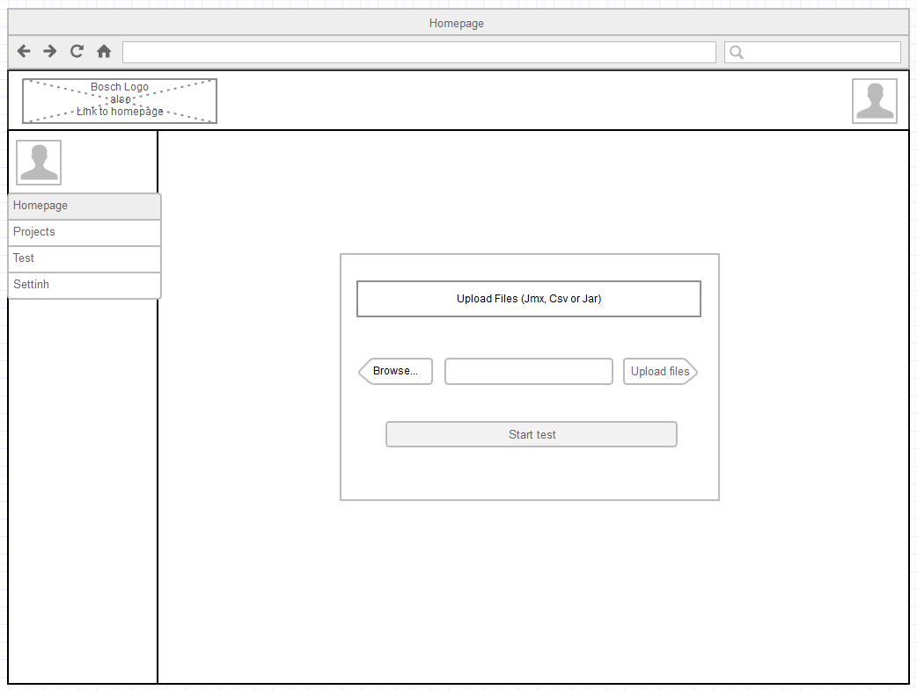

Figure 2: UI Homepage with a Start new Test for “Run a test suite” use case scenarios

|  |  |
| --- | --- |
| **Requirement Tag ID** | **Homepage** |
| Source/Trigger | “Run a test suite” use case |
| Input | |  |  |  | | --- | --- | --- | | **Field Name** | **Type** | **Remarks** | | File Upload | File | script *.jmx, data *.csv, *.txt | |
| Description | User can upload all needed files for a test and be able to run a new test from the homepage. |

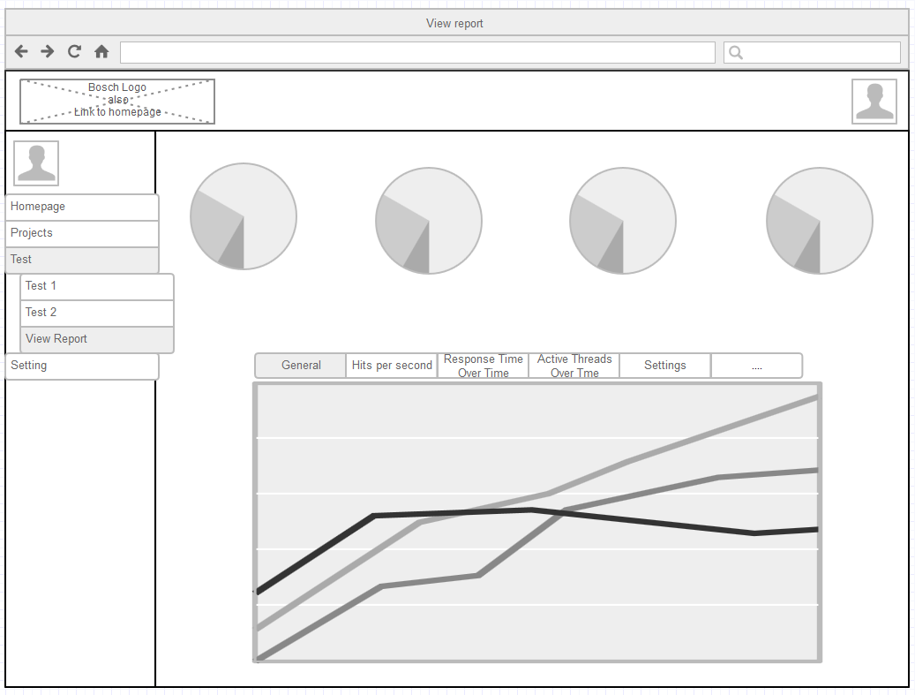

Figure 3: UI View Report for "View final report" use cases scenarios

|  |  |
| --- | --- |
| **Requirement Tag ID** | **View Report** |
| Source/Trigger | “View final report” use case |
| Description | The “View Report” page has to show all final report in this page and user can have ability to choose which graph he/she want to see. |

## External Interface Requirements

N/A

## Special Characteristics

N/A

## Software Safety Requirements

N/A

# Project Execution Related Requirements

## Development Environment

* Windows Operation System.
* Eclipse IDE/ Spring Tool Suite.
* Apache Maven
* Java SE Development Kit 8
* Jmeter Source
* GIT
* Tomcat Server (at least 7).
* MySQL

## Design requirements

* System must be written in Java language using Spring framework.
* System can be deployed on both Windows/Linux OS.
* System must ensure the outputs’ correctness and stability.
* System must use latest technologies for further developments and maintenances.

## Coding requirements

|  |  |
| --- | --- |
| Name | Convention |
| Class name | Should start with uppercase letter and be noun e.g. String, Color, Button, System, Thread etc. |
| Interface name | Should start with uppercase letter and be an adjective e.g. Runnable, Remote, ActionListener etc. |
| Method name | Should start with lowercase letter and be a verb e.g. actionPerformed(), main(), print(), println() etc. |
| Variable name | Should start with lowercase letter e.g. firstName, orderNumber etc. |
| Package name | Should be in lowercase letter e.g. java, lang, sql, util etc. |
| Constants name | Should be in uppercase letter. E.g. RED, YELLOW, MAX_PRIORITY etc. |

## Error handling requirements

* The application will not allow the user to access the system without logged in.
  + - Every visitor must logged in before using the system. If user logged in with administrator account the system will redirect to Admin’s view with full functions and other accounts will be redirected to user’s view with limited functions. If visitor try to directly access by URL, system will redirect to Login Page and display error.
* The application will not allow the user to change information of the project.
  + - User will only have permission to view the project information, admin will have role for create, edit and delete project. On the user’s view Project Management Functions will be disabled, if user try to directly access by URL, system will redirect to Error Page and display warning.
* The application will not allow the admin to delete own account.
  + - System will not limit the number of Administrators so to ensure the security admin cannot delete own account or account with same role. The delete button will be disabled, if admin try to directly delete by URL, system will redirect to Error Page and display warning.
* The application will not allow the user to create tests, accounts or upload files with same name.
  + - If the test/account/email/file already exists in the database, an error message will appears.
* User cannot upload invalid file types.
  + - System will only allow 4 file types: JMX, CSV, TXT and Properties. Other file types will be rejected by system and display error message.
* User cannot upload file more than 5Mbs.
  + - System will check for file size and error message will appear if the file size is more than 5Mbs.

## Resource requirements

The software will be developed in a Windows environment with Java being the primary language.

The Company RBVH has provided four Windows machines, software, and other facilities for use in the project. We also require a server for hosting the web and a system of computers to distribute performance test script.

## Risk management

In this project, the following risk management strategy is employed:

- Assess and track the likelihood and impact of major risks.

- Provide mitigation solutions and contingency plans to all assessed risks.

- Risk reassessment will be done after every sprint.

- When any risk arises, an issue will be reported and solved regarding to corresponding risk response of that risk.

Several risks are listed in the below table.

|  |  |  |  |  |  |
| --- | --- | --- | --- | --- | --- |
| No. | Risk Description | Likelihood (%) | Impact (%) | Mitigation | Contingency |
| 1 | Client withdraws | 10 | 100 | - Maintain communication  - Keep positive relationship | In the case that client is unable to continue the project, the team will contact the faculty to find a substitute |
| 2 | Team member withdraws | 30 | 65 | - Set ground rules and guidelines to avoid conflict.  - Always keep in touch with each other.  - Other withdraw reasons are assumed to be unlikely. | If a team member withdraw, the team will adjust the scope and the schedule. |
| 3 | Main requirements are changed | 30 | 50 | - Manage requirements  - Maintain contact with client and be informed changes ASAP. | When a requirement changes,  - Update SRS.  - Adjust plan and add to backlog. |
| 4 | Level of effort significantly exceeds the estimates of a sprint | 50 | 50 | - Make prototypes and conduct feasibility study at the beginning of each sprint. | - Adjust the schedule when necessary.  - Work overtime if the deadline is fixed |
| 5 | Level of effort significantly exceeds the estimate for the whole project | 70 | 40 | - At the initiating process, identify the effort regarding to the scope | - During execution, negotiate with client to adjust requirements if there any sign of exceeding the planned project effort. |
| 6 | Loss of critical documents or code | 30 | 70 | - Develop a backup plan.  - Back up regularly. | - Use latest backups to recover.  - Work on the missing parts to replace them ASAP |
| 7 | The client is not available | 40 | 40 | - Define regular meetings in advance. | - Reschedule the meeting day to a date when the client is available. |

## Training Requirements

• Necessity

• Person(s) to be trained

• Areas for which training is required.

# Testing Requirements

The Unit testing should be cover around 60% of source code.

|  |  |  |
| --- | --- | --- |
| Item Name | Description | Prepared by |
| Windows 7 – IE11 | Testing environment | RBVH/ETI1 |
| Windows 7 – Firefox 45 | Testing environment | RBVH/ETI1 |
| TFS | Bug tracking system | RBVH/ETI1 |
| TestNG | Library | RBVH/ETI1 |
| Junit | Library | RBVH/ETI1 |

The Unit Testing should follow the entry criteria as followed:

* Must have logon credentials to process testing activities.
* TFS account for logging & tracking defects
* Valid Test data is generated by development team to enable testing
* Architecture design & functional Requirement must be made available
* Separate QA environment with its own web server, database and Application server instance must be available
* All standard software tools including testing tools must have been successfully installed and functioning properly

# Product Quality Characteristics

The applicable product quality characteristics are:

• Usability

* Ease of use: while using the PTD, users can achieve their goals quickly and with few or no errors.
* Intuitiveness: the interface is friendly to users so that they can figure out the working process for the first time use; response messages are comprehensible.

• Reliability

* All the performance test scripts running from the PTD must provide the same result as using the Jmeter testing tool.
* Accuracy of testing results shall not be less than 90% in comparison with other performance testing tools.
* The PTD shall be available for use 24 hours per day, 365 days per year.

• Reusability

* The PTD shall provide API for other internal systems in Bosch.
* Architecture of the PTD must be divided in several modules for further medication.

• Portability

* The product can be deploy on different types of environments supporting cloud operating with Windows or Linux.
* The PTD could be run on a server with the least configuration and set ups.

• Efficiency

* The dashboard application should load fast and help testers reduce the prepared time for testing than the currently using tools.
* The PTD should be able to optimize the resources when running performance tests.

• Maintainability

* The application should be based on a framework and separated into modifiable modules.
* The design of the product must be detailed and comprehensible.

• Functionality

* The PTD shall have sufficient functionalities to support the testers perform their testing tasks, specifically managing test suites, running performance tests and watching theirs real time reports.

# Open Source Usage

|  |  |
| --- | --- |
| OPEN SOURCE SOFTWARE COMPONENTS | LICENSE TYPE |
| ADMIN LTE Template | [MIT License](https://github.com/almasaeed2010/AdminLTE/blob/master/LICENSE) |
| Bootstrap | [MIT License](https://github.com/twbs/bootstrap/blob/v4-dev/LICENSE) |
| Java | [Oracle Binary Code License](http://www.oracle.com/technetwork/java/javase/terms/license/index.html) |
| JMETER | [Apache License](https://www.apache.org/licenses/LICENSE-2.0) |
| Spring Framework | [Apache License](https://www.apache.org/licenses/LICENSE-2.0) |
| STS – Eclipse | [Eclipse Public License](https://www.eclipse.org/legal/epl-v10.html) |

# Other Requirements

N/A

# Legal, Security and Confidential Requirements

|  |  |
| --- | --- |
| Confidentiality Requirements | Follow BOSCH Confidential Policy |
| Security Requirements | Follow BOSCH ISP System |

Several policies listed on BOSCH ISP System:

* Clean Desk Policy – Confidential information is not lying open.
* Lock workstation during short absence
* Password contains at least 10 characters and must be change each 6 months
* Email is used for business purposes
* Personal portable storage devices are not allowed to use at BOSCH
* Software download and installation by user are not allowed. Downloading or using cracked/key gen tool is strictly forbidden, or simply unacceptable
* Disconnect the Internet cable immediately if getting virus. Run OfficeScan to scan your Computer and contact Data Security Partner for support.
* Check for the safety link before access

# Quality Assurance Activities

To ensure the product quality, the development of the dashboard shall apply verification activities and validation activities as the following chart. For more information, refer SRS.

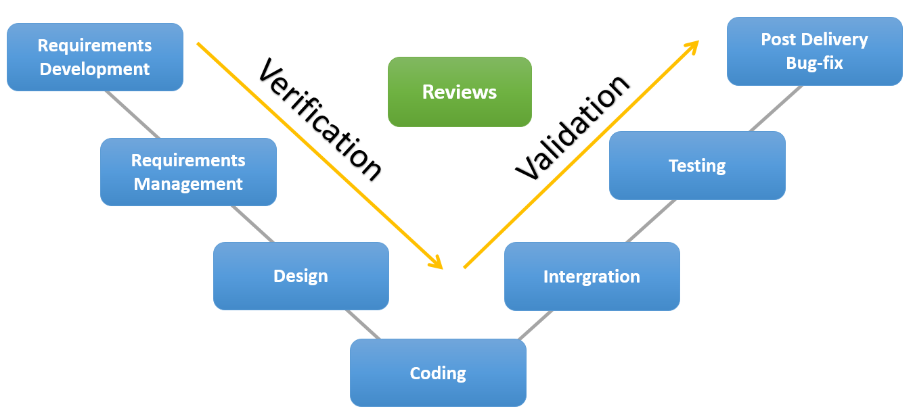

Figure 4 Quality Assurance procedure

# Performance Requirements

Please specify the performance requirements. For example, online response time, efficiency etc.

Please replicate table below of each requirement under this section.

|  |  |
| --- | --- |
| **Requirement Tag ID** | **Usage of the result in the list view** |
| Description | The results displayed in the list view should be user friendly and easy to understand. Selecting an element in the result list should only take one click |
| Rationale | In order to for a user to use the list view easily |

|  |  |
| --- | --- |
| **Requirement Tag ID** | **Usage of the information link** |
| Description | The information link should be prominent and it should be evident that it is a usable link. Selecting the information link should only take one click |
| Rationale | In order to for a user to use information link easily |

|  |  |
| --- | --- |
| **Requirement Tag ID** | **Response Time** |
| Description | The response time between any user interface request and completion of the response must be no longer than 20 seconds |
| Rationale | The system should be quick and responsive to user commands and requests so as not to slow down the user |

|  |  |
| --- | --- |
| **Requirement Tag ID** | **Response Time** |
| Description | The response time between any user interface request and completion of the response must be no longer than 20 seconds |
| Rationale | The system should be quick and responsive to user commands and requests so as not to slow down the user |

# Data Protection and Information Security Requirements

## Data storage

* Documents will be saved on company’s computer and stored in secured disk which will need password to access. All the documents will be updated daily and push to TFS’s (Team Foundation Server) repository.
* Source code must be updated daily and synced between members. Source code will be stored on TFS’s repository.

## Data transmission

Data transmission will follow BOSCH’s policies.

For secure data transmission the Bosch Group provides encryption software complying with international standards. Using this software messages are encrypted and signed digitally.

## Information security requirements:

For the information security must follow these requirements:

* Data must be stored on secured disk company’s desktop.
* Data should not be used outside Bosch’s system.

For individual and other information security for email, internet will follow Bosch’s policy.

 

# Software Acceptance Criteria

The Software Acceptance Criteria that will be used to validate the supplied Software product

* All essential requirements must be completed and delivered on time.
* System must run stably without any technical failure.
* Software will follow Bosch’s intranet policy to ensure system security. Software using Spring security itself to prevent security vulnerabilities.
* Accuracy:
  + - Report from test must be correct for each test suite.
    - Real-time process will executed with delay.
    - Other functions must work stably with correctness.
* System will have clear coding with latest technologies and up-to-dated documents for further maintenance or development
* System will have simple and clear interface with sensible arrangements to increase User Experience. System was also be made responsive to compatible with various devices.

# Deliverables

## List of Deliverables

|  |  |  |
| --- | --- | --- |
| No. | Deliverables | Schedule |
| 1 | Proposal | 10/12/2016 |
| 2 | Standards | 10/22/2016 |
| 3 | SRS | 10/24/2016 |
| 4 | Design | 10/24/2016 |
| 5 | Prototype | 10/24/2016 |
| 6 | Code | 6/1/2017 |
| 7 | Test plan | At the beginning of each sprint |
| 8 | Go live | 6/2/2017 |
| 9 | Technical Document | 6/1/2017 |
| 10 | Training plan | 6/1/2017 |
| 11 | Project documents | 6/5/2017 |

## Installation Support

Identify the support to be provided by RBVH in installing the Software.

RBVH shall allow the project team to install packages mentioned in the operational requirements on the PCs which RBVH provides.

## Delivery

• Medium of delivery

* Documents will be uploaded on the Bosch ILM (internal configuration management system).
* The product code will stored on the Team Foundation Service of Bosch.

• Characteristics

* Documents will follow Microsoft format and common extensions.
* The code of the application shall not be compressed.
* The deploy file of the PTD must be *.war or *.ear.

• Replication

* Backup shall be provided by Bosch’s CI.

# Requirements Acceptance Statement

The RBVH representative and the project team accepts the SRS and agree to be bound by all the above mentioned requirements.

# Annexure

The supporting information makes the SRS easier to use. It includes:

• Index

• Appendices

The Appendices are not always considered part of the actual requirements specification and are not always necessary. They may include:

(a) Sample I/O formats, descriptions of cost analysis studies, results of user surveys

(b) Supporting or background information that can help the readers of the SRS

(c) A description of the problems to be solved by the software

(d) Special packaging instructions for the code and the media to meet security, export, initial loading, or other requirements

When Appendices are included, the SRS should explicitly state whether or not the Appendices are to be considered part of the requirements.

## References

In this subsection:

(1) Provide a complete list of all documents referenced elsewhere in the SRS

(2) Identify each document by title, report number (if applicable), date, and publishing organization

(3) Specify the sources from which the references can be obtained.

This information can be provided by reference to an appendix or to another document. If your application uses specific protocols or RFC’s, then reference them here so designers know where to find them.

REFERENCES

|  |  |  |  |  |  |
| --- | --- | --- | --- | --- | --- |
| No. | Title | Version | Author | Date | Source/Location |
| 1 | Java coding standards | 1.0 | Bosch | 10.1.2016 | ProView |
|  |  |  |  |  |  |
|  |  |  |  |  |  |
|  |  |  |  |  |  |